Chapter 2 Geological time
Extra worksheet 2: Dinosaurs and extinction
Science Understanding Verbal/Linguistic
Name: Class: Date:

Extinction
Extinction means the death of all organisms of a particular species. About 65.5 million years ago there was a ‘mass extinction event’, meaning many species became extinct at the same time, and fairly quickly. In some groups every species died, including all the dinosaurs. This extinction is called the
K–T extinction or the Cretaceous–Tertiary extinction. The causes of the extinction are still being researched and several different theories have been proposed, including climate change, asteroid impact, volcanic eruptions, change in food supply or sex ratios.

Climate change
During the Mesozoic era the climate was much milder (warmer) than it is now. There were no ice caps, sea levels were much higher, and there was less difference in temperature between the poles and the equator. Carbon dioxide levels were more than ten times higher and there was a lot more oxygen in the atmosphere.
These conditions seem to have changed in the late Cretaceous. If oxygen levels also fell at this time and dinosaurs breathed as birds do today, then the dinosaurs may have had great difficulty getting enough oxygen into their bodies. Another possible cause of the extinction is that dinosaurs would have been unable to regulate their body temperatures in a colder world.

Asteroid impact
In 1980, a scientist called Walter Alvarez and others scientists were studying a rock layer from Italy which dated to the time of the K–T extinction. They found that the rock layer had a very high level of a rare metal called iridium in it. Iridium is more common in asteroids and comets than on Earth. Much of the iridium on Earth falls as dust from the atmosphere due to meteorites burning up. The only other source of iridium is volcanic activity. This led to the hypothesis that a large object hit the Earth and deposited an unusually large amount of iridium.
Some studies have concluded that an asteroid hit the Earth near the time of the extinction and that this asteroid formed the Chicxulub Crater in Central America (Figure 1). However, another study found that the Chicxulub asteroid hit the Earth about 300 000 years before the extinction. That research also suggested that the high iridium levels may be explained by volcanic activity.
If an impact did occur around the time of the extinction, then it could have caused a rapid heating of the Earth, followed by a rapid cooling as the dust thrown into the atmosphere reduced the amount of sunlight reaching the ground. More research is needed to decide if the asteroid theory is correct.
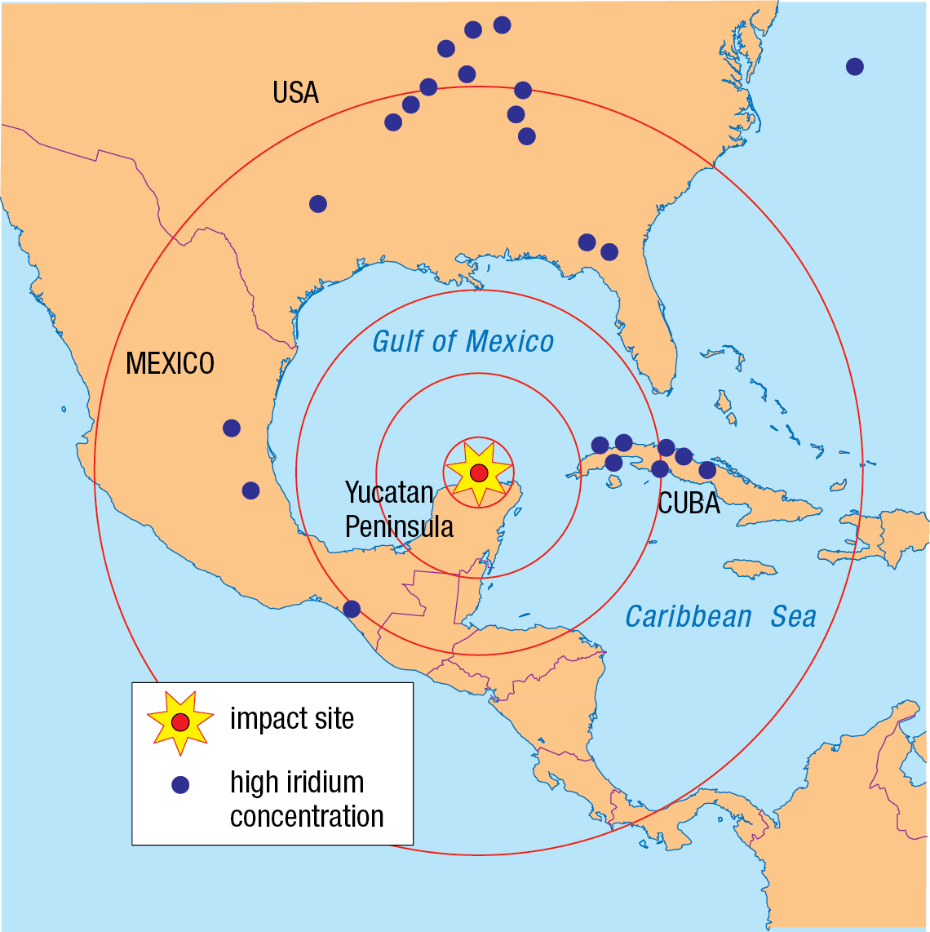
Figure 1
The site of a possible asteroid impact on the Yucatan Peninsula.

Volcanic eruption
Another theory for the cause of the extinction is that volcanoes erupted in what is currently the Deccan region of India (Figure 2). These volcanoes covered an enormous area, about half the size of India, and rock from them has been dated to 65.5 million years ago. The eruptions would have released dust and other material, including iridium, into the air. This material might have blocked sunlight and so reduced photosynthesis in plants. There were clearly changes in the Earth’s climate at least half a million years before the extinction of dinosaurs, which corresponds with the date of eruption of the Deccan volcanoes. However, much more data is needed to show the significance of these eruptions.

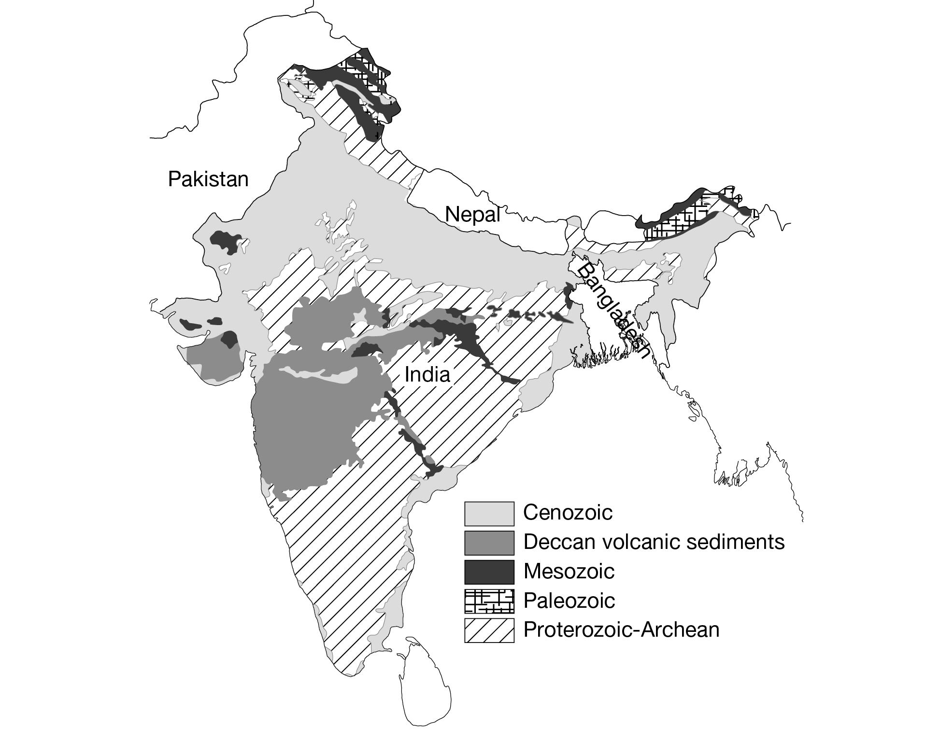
Figure 2
The Deccan Traps, site of a massive series of volcanic eruptions that may have been involved in the extinction of the dinosaurs.

Change in food plants
There was a great change in the plant fossils during the middle to late Cretaceous period. The gymnosperms which dinosaurs had been feeding on largely disappeared and a new flowering type of plant appeared in the fossil record. Fossilised dinosaur dung indicates that most dinosaurs kept eating the gymnosperms. This could mean that the dinosaurs were unable to adapt to a new diet of flowering plants when the gymnosperms disappeared. Much more data is needed for this hypothesis.

Sex ratio changes
A new theory proposes that a brief period of rising temperatures changed the proportions of males and females in the dinosaurs. Crocodiles are modern-day relatives of the dinosaurs. If the temperature rises, then more male than female crocodiles are born. A crocodile egg can develop into either sex depending on the temperature at which it develops. If dinosaur eggs were affected by temperature in the same way, then perhaps there were not enough females born if the climate warmed.

Questions
1 a Name the mass extinction in which the dinosaurs perished.

b State when it occurred.

2 List the possible reasons for the K–T mass extinction.

3 Define the term extinction.

4 Summarise the evidence for and against the asteroid impact theory for the K–T mass extinction.

5 Summarise the evidence that supports a volcanic eruption cause for extinction.

6 Propose ways in which the changing temperature of the Earth could have caused dinosaur extinctions.

7 Propose how dust in the atmosphere from an asteroid impact may have affected plants.

